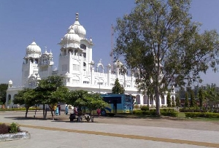

Patalpuri Temple and Undying Banyan

Patalpuri temple and the Undying Banyan, Allahabad in Uttar Pradesh in India, are both situated in close proximity with each other on the same site. Patalpuri temple is situated in the Allahabad fort and is one of the Holy Places in Allahabad. The Patalpuri Temple, Allahabad is one of the most famous and oldest temples not only in Allahabad but also in India. Undying banyan tree also referred to as the 'Akshayavat' is again regarded as a holy tree. About the Undying Banyan Tree it is said that this tree would stand firm even when the entire world gets destroyed. The Patalpuri Temple and the Undying Banyan Tree at Allahabad in Uttar Pradesh in India is a major Tourist’s Attraction inAllahabad.During the reign of Akbar, Akbar built the Allahabad Fort over the temple in the year 1583 and since then the temple lies within and under the fort. As per the Indian mythologies it is said that Lord Rama and Prahalada has also come to visit this old temple. Huan Tsang is also said to have visited the Patalpuri Temple and the Undying Banyan Tree at Allahabad in Uttar Pradesh in India. The Patalpuri Temple and the Undying Banyan has been stated in many ancient scriptures. Indian Mythologies state that people in the olden days use to throw themselves from the Undying Banyan Tree to attain salvation.

# https://www.indianholiday.com/pictures/travelguide/attractions/hanuman-temple-1661.jpeg

# Hanuman Temple

Hanuman Mandir, Allahabad is a unique temple situated near the Allahabad Fort. Hanuman Temple, Allahabad in Uttar Pradesh in India is famous for being the only temple where Lord Hanuman is seen in a recline posture. The Hanuman Temple is a very Holy Place in Allahabad in Uttar Pradesh in India.

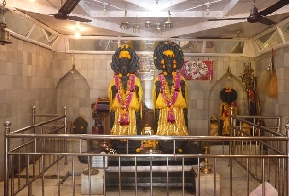

# Nag Basuki Temple

Nag Basuki Temple, Allahabad is situated on the bank of the river Ganges. Nag Basuki Temple is located in Daraganj which lies on the northern side of the railway bridge. Nag Basuki Temple in Allahabad in Uttar Pradesh in India is dedicated to Nag Basuki. The big idol of reclined Bhishmapitamah lies adjacent to the temple. Nag Basuki Temple, Allahabad is among the Holy places in Allahabad in Uttar Pradesh in India. Every year on the occasion of Nag Panchami a fair is held near the Nag Vasuki Temple in Allahabad at Uttar Pradesh in India.

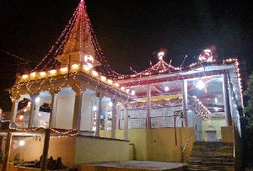

# Someshwar Mahadev Temple

Someshwar Mahadev Temple in Allahabad is one among the many holy places in Allahabad. Someshwar Mahadev Temple is an ancient temple which is situated opposite to the Allahabad Fort across Sangam in the Arail area. The Someshwar Mahadev Temple is dedicated to Lord Shiva. Someshwar Mahadev Temple is situated in Naini in Allahabad across the holy river Yamuna.



# Sangam Allahabad

One of the most known holy places at the confluence of three rivers the Ganga, Yamuna and Saraswati, Sangam is visited by thousands every year. Sangam, Allahabad is one of the most famed Holy Places in Allahabad and is an essential part of the Allahabad Tour. Sangam in Allahabad in India is also a major Tourists Attractions in Allahabad.

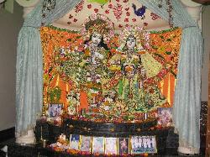

[Hare Rama Hare Krishna](https://www.tripadvisor.in/ShowUserReviews-g1162488-d3161379-r403932738-ISKCON_Allahabad_Sri_Sri_Radha_Venimadhav_Temple-Allahabad_Allahabad_District_U.html#REVIEWS)

ISKCON temple i always wanted to visit. They are always best maintained and neat and clean. I like to attend morning Aarti. I feel blessed at ISKCON temples. Been to most of the temple in our country but found this one nested in the residential buildings. Idols of Lord krishna are very beautiful and you feel relaxed and blessed.